
Ciencia y Progreso
Publicada en línea: abril, 2023, RNPS: 2477, ISSN: 2707-7098
http://cienciayprogreso.cug.co.cu



El aprovechamiento de la jornada laboral en la Empresa provincial de transporte Guantánamo
The use of the working day at Guantánamo Provincial Transport Company

Yordanis Maturell-Montoya; José L. Brugal-Ramírez; Rachel Laborit-Cruz
Universidad de Guantánamo, Guantánamo, Cuba
Correo(s) Electrónico(s)
yordanismm@cug.co.cu
joselb@cug.co.cu
rachellaborit1@gmail.com
ORCID: https://orcid.org/00000002-6878-1777
https://orcid.org/00000002-9451-8091
https://orcid.org/00000003-0899-9501
Recibido: 15 de abril de 2022
Aceptado: 3 de noviembre de 2022
Resumen
La presente investigación se realizó en la Empresa provincial de transporte Guantánamo, con la finalidad de realizar un estudio del aprovechamiento de la jornada laboral. Para ello, se utilizaron diferentes métodos, software y herramientas que hicieron posible el cumplimiento del objetivo de la investigación, entre ellos: histórico-lógico, inductivo-deductivo, anlalisis-sintesis, así como, la entrevista, la observación y la técnica de fotografía individual. Como resultado se comprobó que la Empresa provincial del transporte Guantánamo posee un aprovechamiento de la jornada laboral del 84.2 %. Dentro de las causas que más inciden se encuentran la existencia de pérdidas de tiempo e interrupciones no reglamentadas que resultan significativas, causadas fundamentalmente por violaciones de la disciplina laboral, obsolescencia tecnología, incontigencia energética e insuficiente organización del trabajo, entre otras.
Palabras clave: Organización del trabajo; Jornada laboral; Aprovechamiento de la jornada laboral; Productividad.
Abstract
The current research was carried out in the provincial transport company of Guantánamo with the purpose of carrying out a study of the use of the working day. For this, different methods, software and tools were used that made it possible to fulfill the objective of the research, among them: historical-logical, inductive-deductive, analysis-synthesis as well as interview and observation and the individual photography technique. As a result, it was verified that the provincial transport company Guantánamo has a use of the working day of 84.2 %. Among the causes that most affect are: the existence of loss of time and unregulated interruptions that are significant mainly caused by violations of labor discipline, technological obsolescence, energy incontinence and insufficient organization of work, among others.
Keywords: Organization of work; Workday; Use of the workday; Productivity.
Introduction
In Cuba, the current development and improvement of production processes increasingly requires the efficiency and effectiveness of individuals, teams and organizations, where many authors, such as (Ávila et al. 2018; Catá 2017; Nuñez, 2018; Pulido, 2018 and Zayas, 2020), recognize that the human factor is the most important for the achievement of this objective. Coupled in turn to business improvement with the aim of improving productivity, quality and effectiveness indexes at the lowest possible cost.
Problems found from initial explorations and inquiries, such as labor indiscipline of workers, insufficient salary motivation, delays at the beginning and during the workday, instability in the performance of jobs, insufficient personnel training, underutilization of effective capacities of the existing equipment, low productivity, are an attempt against the fulfillment of the aforementioned purposes.
For this reason, and as part of the implementation of Decree Law 53 of 2021, approved by the Council of Ministers, with the purpose of improving the salary retribution in the state enterprise system, it is necessary to study the use of the working day for its implementation in the organization.
Hence, the present research is carried out in the Guantánamo Provincial Transport Company with the objective of measuring the use of the working day and thus proposes actions for the optimization of the work force in that organization.
Development
According to Infante and Gonzalez (2012),
The organization of work in labor entities integrates human resources with technology, means of work and materials, through the set of methods and procedures applied to work with adequate levels of safety and health, ensuring the quality of the product or service provided and compliance with the established ergonomic and environmental requirements. (p. 5).
Similarly, Rosell et al. (2020), within it, the correct use of the working day is an important factor in the development of companies, with the application of correct work techniques and the elimination of unproductive time, allowing increasing work productivity, efficiency and effectiveness of the organization.
The workday or working day has been defined in different ways and by various authors. For the present research we assume the definition provided by González (2022), who defines it "as the number of hours that a worker dedicates to the performance of his work throughout a day, although it could be contemplated in weekly or monthly periods" (p. 11).
Within them there are different types:
- Reduced working day: there are jobs where the working day may be reduced due to personal physical circumstances, such as jobs with health risks, work inside mines, work in cold storage rooms, etc.
- Continuous working day: consists of a break of fifteen to thirty minutes.
- Split day: when the interruption in the working day is at least one hour.
- Shift work: consists of rotating work shifts among all the workers that make up the team, alternating morning, afternoon or evening.
- Night shift: when working hours have been established from 10 p.m. to 6 a.m. the following day.
- Working hours on public holidays: when working on holidays.
- Overtime: are the actual hours of work that exceed the maximum duration of the working day, which may not exceed 80 hours per year.
- The working day is structured according to the time expenses that are present in the working day, which can be classified as follows:

Task-related work time (TRWT): is the time spent by the worker to perform the actions that ensure the fulfillment of the main job. This time includes the following expenses, as established by the position qualifier, the production or service task, which must be performed in the job he/she occupies, in accordance with the characteristics of the work process and its classification
It has three fundamental components, which are:
- Conclusive preparatory time (CPT)
- Operating Time (OT)
- Service time (ST)
Non-Task Related Work Time (NTRWT): is the time that the worker spends on tasks not foreseen in his job content, whether caused by fortuitous needs of production, deficiencies in the organization of work or violation of technological discipline. This work expenditure for a given operation only when the technical-organizational conditions are optimal.
Regulatory outage time (ROT): is the time that the worker does not work for reasons foreseen or inherent to the work process itself. It has two fundamental components:
- Regulatory downtime due to technology and established work organization (RDDTEWO)
- Time of rest and personal needs (TRPN)
Time of non-regulatory interruptions (TNRI): is the time that the worker does not work due to alteration of the normal work process. It has four components:
- Time of interruptions due to technical-organizational deficiencies in the process (TITO)
- Time of interruptions for violation of labor discipline (TIDO)
- Time of interruptions due to casual problems (ICT)
- Time of interruptions for other organizational causes (TIOC)
The time expenditure of the working day can also be structured according to standard and non-standard times.
Normalizable times (NT): it is composed of task-related working time (TTR) and the time of regulated interruptions.
Non-standard time (NRT): this is composed of non-task-related working time (NTWT) and non-regulated break time (NTRT).
Both classifications are the basis for analyzing the use of the working day, making it possible to detect the different interruptions that can occur during the working day, as well as the causes that give rise to them.
Sample and methodology
The work is based on the qualitative-quantitative paradigm, as well as the use of methods such as observation, interview and documentary analysis. Software such as Metrab and SPSS v21 were also used.
For the measurement of the use of the working day in the Guantánamo Provincial Transport Company, individual photography was used as a methodology for the work. The sample was chosen randomly in eight departments of the entity under study with a total of 48 workers.
Individual photography is preferably applied when dealing with non-repetitive tasks, although due to its characteristics, it is a widely used technique. It consists of observing the selected worker, directly and continuously, placing the supervisor in a convenient position so that he does not interfere with the worker in the execution of his work and at the same time it is possible for him to see without difficulty, what he does to make a detailed description of everything that happens during the workday and measure all time spent using a clock, recording everything in a model conveniently equipped for this purpose as González (2022) refers.
Its objectives are:
- Determine the existence and magnitude of variable and constant times.
- Detect non-standard times and the causes that provoke them.
- Determination of the use of the working day (AJL).
Stages in its use
1. Preparation of observations.
2. Making observations.
3. Information processing and analysis.
4. Determination of the means of the total observations and calculation of the norm.
As a prelude to the study, a series of tasks were carried out, including the following:
- A training course related to decision making tools, workday utilization and continuous improvement as methods for organizational development.
- A procedure for the integral study of the organization presented to the Board of Directors for subsequent implementation.
- A work team made up of professors and students from the University of Guantánamo, as well as workers from the Guantánamo Provincial Transportation Company, was organized.
- A work schedule based on the study of the subsystems agreed with the organization.
Results
The procedure sets out the following steps chronologically:
Stage 1. Select the work(s) to be studied.
The company determined that all areas of the management center would be surveyed, except for the trainees. Seventy percent of the covered workforce was sampled. As part of the time study, direct observation, timekeeping and individual photography were used.
By labor categories, 91 % of the technicians (40 out of 44), 80 % of the service personnel (four out of five) and 25 % of the workers (three out of 12) (this group is made up of drivers) were studied. For the selection of workers to be observed, the predominance of technical positions (64 %), workers (17 %), managers (12 %) and services (7 %) was taken into account by category. Of these, workers are mostly composed of drivers.
Step 2. Record data relating to the circumstances under which the work is carried out.
Next, in the process, the necessary data were obtained to carry out the time study. To carry out the initial measurements, we began with detailed observations of the entire day at the different work stations with the objective of:
- Determine the utilization of the working day.
- To analyze the indicators that affect the productivity of the working day.
- Detect and analyze the main problems present in the area studied.
By means of individual photography, the activities of each worker were analyzed by department, as well as the completion times, interruptions and delays. Three daily observations were made per worker, during three working days.
Interviews, measurements, observations and the timing of work times by departments and workers were carried out during the month of February 2022, by a group of third and fourth year students of the Industrial Engineering career, supervised by professors of the department of the mentioned career, belonging to the University of Guantánamo, with the internal support of the human resources area and the management of the entity under study.
Table 1 shows the results of the measurements made by areas, it is worth mentioning that all the duration times are expressed in minutes/JL.
Table 1. Results of the measurements made by areas
Áreas | TPC | TO | TIRTO | TDNP | TITO | TIDO | TIC | TIOC | JL
Dirección | 22 | 326 | 21 | 7 | 0 | 42 | 51 | 11 | 480
Operaciones | 15 | 326 | 29 | 9 | 0 | 66 | 28 | 8 | 480
Carga | 13 | 434 | 0 | 6 | 0 | 10 | 9 | 7 | 480
Técnico | 12 | 349 | 13 | 7 | 0 | 77 | 7 | 16 | 480
Economía | 15 | 376 | 29 | 10 | 0 | 65 | 28 | 3 | 527
R. Humanos | 15 | 443 | 0 | 9 | 0 | 7 | 7 | 0 | 480
Abastecimiento | 12 | 369 | 12 | 9 | 0 | 131 | 9 | 0 | 540
Servicios Internos | 16 | 396 | 29 | 9 | 0 | 10 | 33 | 4 | 497
Total | 15 | 377 | 17 | 8 | 0 | 51 | 21 | 6 | 495
Fuente: Elaboración propia
Step 3. Examine the recorded data and separate productive from unproductive areas and workers.
After the three initial observations have been made, we proceed to the analysis of the working hours, taking into account its structure by areas, positions and workers.
We proceed to determine each of the times of the working day taking into account its structure. Table 2 below shows the summary of the times present in the initial observations of the full day in each of the departments studied, expressed in minutes/JL per worker).
Table 2: Average duration of the working day and work and interruption times by areas
Áreas | TPC | TO | TIRTO | TDNP | TITO | TIDO | TIC | TIOC | JL
Dirección | 22 | 326 | 21 | 7 | 0 | 42 | 51 | 11 | 480
Operaciones | 15 | 325 | 29 | 9 | 0 | 66 | 28 | 8 | 480
Carga | 13 | 435 | 0 | 6 | 0 | 10 | 9 | 7 | 480
Técnico | 12 | 348 | 13 | 7 | 0 | 77 | 7 | 16 | 480
Economía | 15 | 330 | 29 | 10 | 0 | 65 | 28 | 3 | 480
R. Humanos | 15 | 442 | 0 | 9 | 0 | 7 | 7 | 0 | 480
Abastecimiento | 12 | 307 | 12 | 9 | 0 | 131 | 9 | 0 | 480
Servicios I | 16 | 379 | 29 | 9 | 0 | 10 | 33 | 4 | 480
Total | 120 | 2892 | 133 | 66 | 0 | 408 | 172 | 49
Promedio | 15 | 361,5 | 16,625 | 8,25 | 0 | 51 | 21,5 | 6,125 | 480
Fuente: Elaboración propia
When evaluating the average working hours by area, it was found that:
- In eight work areas studied, out of a total of 1205 observations, 600 (49.8 %) correspond to regulated work times and 605 (50.2 %) to non-regulated interruptions.
- The preparatory-conclusive time (TPC) ranged between 12-22 min/JL and, in 2 areas (Internal Services and Management), the 15 min/JL established by several authors as the average norm per working day was exceeded.
- The operating time (TO) ranges between 326-443 min/JL and the best use of this indicator is made by the Human Resources and Loading areas, while the Management and Operations areas show the lowest average records.
- Regulated technical-organizational interruptions (TIRTO) range from 0-29 min/JL, the areas with the highest incidence in Internal Services, Economy and Operations.
- Labor discipline violations (TIDO) range from 7-131 min/JL, with the Procurement area having the highest average record for this indicator.
- Casual interruptions (TIC) range from 7-51 min/JL, with the Management area showing the highest average for this indicator.
- Interruptions due to other organizational causes (TIOC) range from 0-16 min/JL, with the Technical area showing the highest average record for this indicator.
The Technicians category loses 79 min/JL per worker on average and has the greatest negative impact on the inefficient times recorded in the observations.
They obtain an average level of operating time utilization with respect to the duration of the Workday (TO/JL) per worker (they are ordered in decreasing order):
- Below 80% for the following positions: Secretary, Transport Traffic Inspector, Safety and Security Technician, Motor Transport Specialist A and Technician A in Attention to the Population.
- Below 70% the positions: Specialist C in Saving and Rational Use of Energy, Specialist B in Economic Management, Technician A in Economic Management, Reception Clerk and Telephone Board.
- Below 60%, the positions of Computer Science Specialist B, Investment Technician, Fleet Control Supervisor B, Technician A in Motor Transport, and Cadre Specialist B are all below 60%.
Calculation of working time utilization
After determining each of the times that are present in the initial observations, the workday utilization is determined for the 3 days observed for each area, and the workday utilization is determined using the expression:
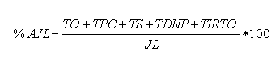
Where: TO-Operational time; TPC-Conclusive preparatory time; TS-Service time; TDNP-Rest and personal needs time; TIRTO-Regulated technical interruption time; JL-Working day duration time. Figure 1 below summarizes the results obtained:
Graph 1: Composition of the working day. 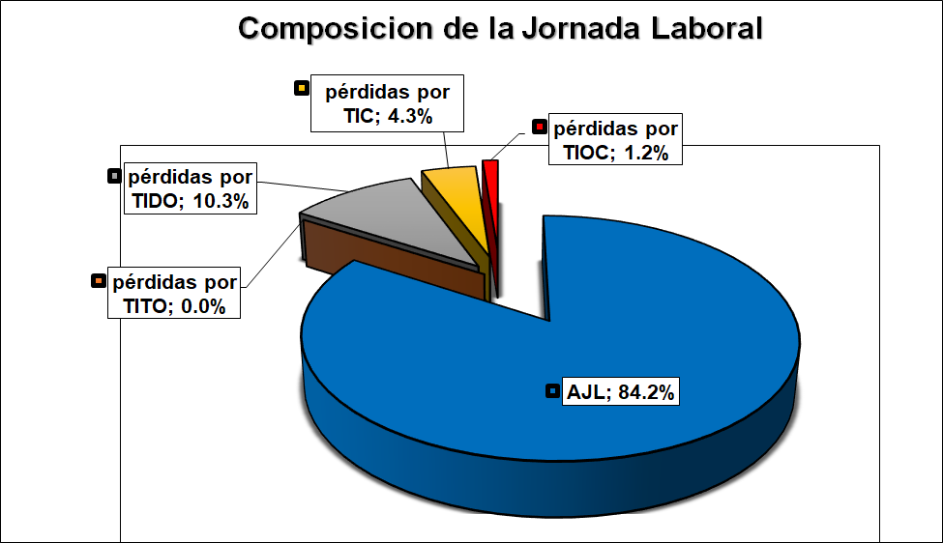
Fuente: Elaboración propia
It is estimated that 84.2 % of the working day is used and 15.8 % of the working day is wasted.
Workday utilization by work areas ranges from 74.2 - 94.6 %, the lowest values being detected in Supply, Management, Operations and Technician, in that order (below 80 %).
From the result of completing the photographs taken, the average losses and utilization in % are obtained for each of the labor categories. Technicians is the category that has the greatest impact on the AJL with an average loss rate of 13.2 %.
The positions with workday utilization rates (AJL) below 80 % are, in decreasing order, the following: Technician A in Attention to the Population, Specialist B in Computer Science, Technician in Investments, Technician A in Economic Management, Supervisor B in Fleet Control, Technician A in Motor Transport and, Specialist B in Cadre.
Step 4 Measure the amount of work performed in each area.
The actual workload in each area was measured by separating the operating time from the inefficient or idle times present in the observations made, as shown in Graph 2.
Graph 2: Composition of the workday by work areas
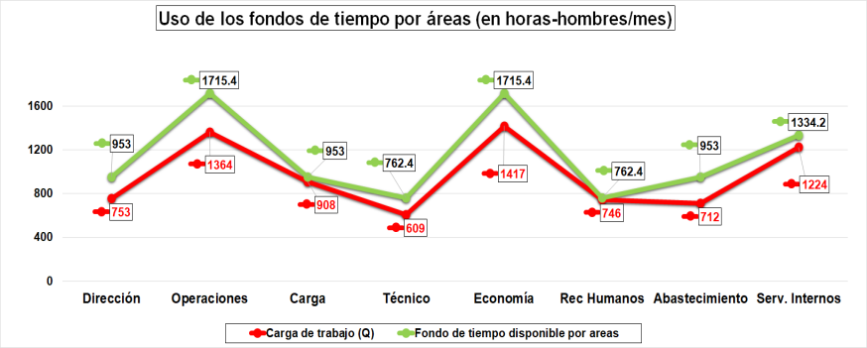
Fuente: Elaboración propia
It is observed in the areas that, the total workload used in the month of February 2022, during the three days of observations made, is significantly lower than the legislated duration of the workday (this is consistent with the existence of unproductive times in the workday), except in Human Resources and Cargo where the difference does not exceed 50 man-hours/month.
The above has its causes in different elements among which are:
In the case of the time of interruptions regulated by the established technology and organization, the loss of time (TIRTO), amounts to 133 minutes (2.21 hours), with an average of 17 minutes. This is due to the following causes:
- The unavailability of technical equipment (printers, printer toners, office supplies) that would allow the functions to be carried out efficiently. At times there were delays of up to 20 minutes in the process of printing documents.
- At the same time, the energy shortage caused delays in activities related to the worker's fundamental activity. Such is the case of the Economics department because its accounting was automated.
- Another problem in this area was the frequent breakage of equipment, which caused delays in the work of the employees.
In relation to the service time (TS), the standard is 30 minutes, however, given that the company does not have a workers' canteen, workers must manage their meals, which causes a delay of up to two hours in restarting the workday.
The loss of time due to unregulated interruptions (TINR) is concentrated in non-productive activities, such as: excessive use of mobile technology, conversations during working hours, and personal errands during working hours.
Also worth mentioning is the loss of interruption time due to organizational causes (TIOC), due to insufficient organization of work and insufficient communication between work areas.
Calculation of staffing requirements
In the time study, the information on the load and capacity of each worker was processed, as well as the number of workers per department.
For the calculation of the load and capacity, the entity's unitary available time fund (Ft = 190.6 hours/month per worker) was taken into account, which is shown in graphs 3 and 4.
Gráfico 3. Plantilla calculada por área Gráfico 4. Comparación plantilla actual la calculada
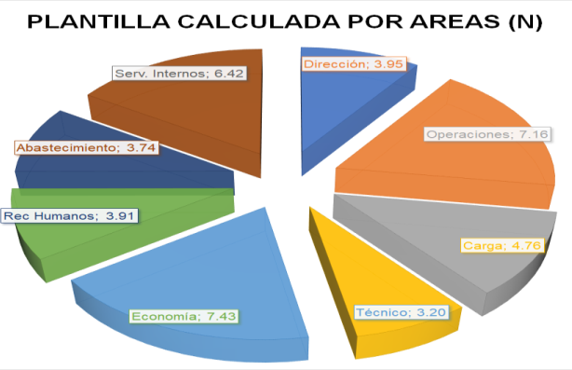
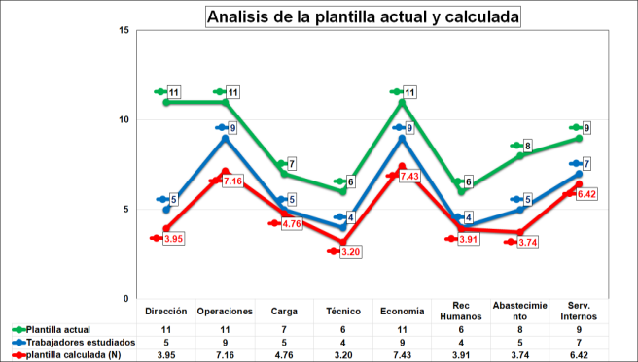
Fuente: Elaboración propia
Having compared the studied and calculated staffing levels, it can be seen that eight positions are required to be reduced in the management center, as shown in Table 3.
Table 3: Calculation of staffing requirements
Cargos estudiados | Plantilla  Estudiada  (trabaj) | Carga de Trabajo  (horas-hombres) | Fondo Tiempo  (hrs/mes-trabaj) | Plantilla  Calculada  (trabaj)  CT/FT | Plantilla  Disponible  (trabaj)  PA-PC
Total general | 48 |  | 190.6 | 40.58 | 7.42

Fuente: Elaboración propia
In order to determine the actual number of personnel required, the specifications and requirements of the job profiles identified with undesired deviations throughout this study must be studied in greater depth, as well as the forms of future work distribution, based on the study of the times previously analyzed.
Step 5. Compile the standard time of the working day in the designated areas and positions.
Once the studies were completed, we proceeded to determine the standard workday time by area in order to verify which positions could be separated or merged in future interdepartmental divisions of labor through additions to the activities, positions or responsibilities of the designated positions. This resulted in the elimination of five existing positions: distributor balancer, motor transport specialist A, transport traffic inspector, motor transport technician A and technician A in economic management.
Step 6. Define standardized working times
Once the data had been collected using one of the methods mentioned above, the average time used by the workers during their workday was determined. These are in accordance with the current legislation of 190.6 hours/month per worker in most of the positions existing in the entity.
These studies were disaggregated by work areas, positions and labor categories of the current workforce versus the workforce studied by the researchers. An acceptable use of operating time per worker would be close to 85% of the working day without the regulatory interruptions, which represent about 11.5% in the summarized observations.
Once the data was collected, the increases were defined by eliminating idle time, inefficiencies and time wasting, the basis for future improvements will be laid. Eliminating wasted time due to labor discipline violations could increase by 13.5 % the utilization of operating time in the organization, as shown in Figure 6.
Graph 6. Increase in working times by area
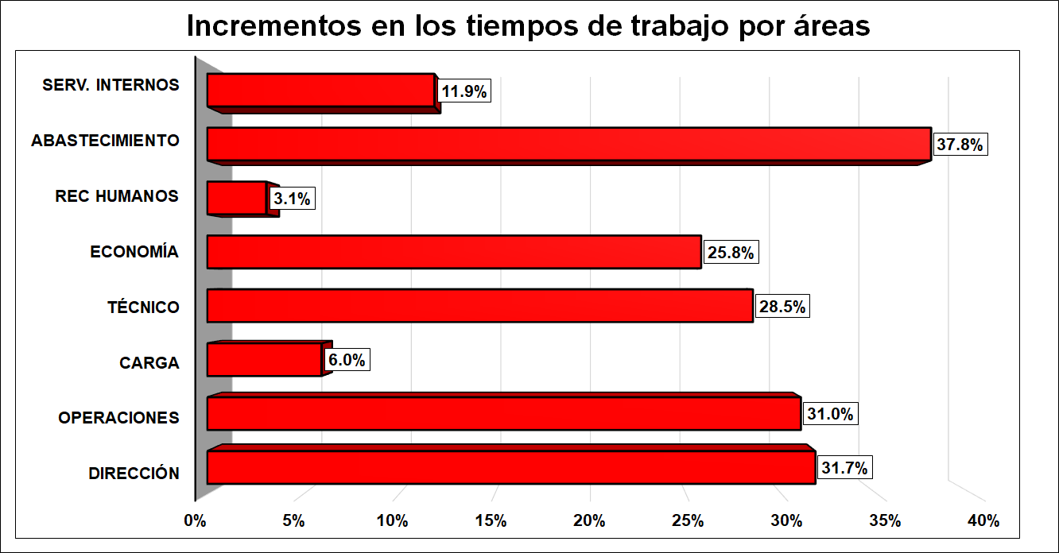
Fuente: Elaboración propia
Intensive technical-organizational solutions would allow an average increase of 31% in the utilization of operating time per area in Procurement, Operations, Management, Technical and Economics.
Discussion
In this stage, the results of the observations made are analyzed. Subsequently, we conclude on the calculation of the AJL and the determined Load and Capacity, making a qualitative analysis on its meaning in the current technical-organizational conditions. At the same time, the productivity increase reserves can be highlighted through the already known expressions. Then we proceed to the elaboration of the final report, including in detail all the results that were obtained in the process.
The information obtained is processed, and it is verified that the Guantánamo Provincial Transport Company has an 84.2 % utilization of the working day, with a 15.8 % wastage. Among the causes that most affect the poor utilization of the working day are: the existence of time losses and unregulated interruptions that are significant, caused mainly by violations of discipline and relaxation of work discipline (TIDO), poor management and control methods, lack of motivation of workers, among others. Time losses by areas range from 2.8 - 25.8 %, the highest values are obtained in Supply, Management, Operations and Technical.
There is a group of positions that have the greatest impact on the recovery and use of idle time and the elimination of losses in the entity's workday. These positions are: Supervisor B in Fleet Control, Distributor Balancer, Technician A in Motor Transport, Specialist C in Saving and Rational Use of Energy, Specialist B in Economic Management, Specialist B in Computer Science, Investment Technician, Technician A in Economic Management, Specialist A in Motor Transport.
Conclutions
The research carried out made it possible to measure the use of the working day in the Provincial Transport Company of Guantánamo, showing as a result that, in general, 84% of the working day is used, mainly due to loss of time related to the excessive use of mobile technology, carrying out personal tasks during working hours, insufficient work organization and shortages of resources necessary for the work, such as office supplies, fuels, among other causes. The calculation of the required workforce showed that the company could dispense with eight positions by merging with others of a similar nature.
Bibliographic reference
Catá, E. (2017). La organización del trabajo en Cuba. Universidad de La Habana.
González, P. (2022). Qué es es la Jornada Laboral | Glosario. Billin. https://www.billin.net/glosario/definicion-jornada-laboral/
Infante, M. C. y González, C. (2012). Estudio de la organización del trabajo en puesto de trabajo seleccionado el caso de una agencia de viajes. TURyDES, 5(12).
Avila, N. S. y González, M. L. (2018): Procedimiento para el análisis del aprovechamiento del capital humano y la fluctuación laboral en organizaciones cubanas. Revista Observatorio de la Economía Latinoamericana, (septiembre 2018).
Nuñez, Y. (2018). Estudio de organización del trabajo en el área de ofimática de la división copextel S.A. Guantánamo. [Tesis de grado, Guantánamo]. Archivo digital.
Pulido, R. de A. (2018). Propuesta de mejoras al aprovechamiento de la jornada laboral en el Taller de Preparatoria 1 de la Textilera “Desembarco del Granma”. Inédito.
Rosell, C., Jocik Hung, G., Ramírez, L., Rosell, R., Ulloa, M., y Ramírez, A. G. (2020). Metodología para la evaluación del aprovechamiento de la jornada Laboral. Archivo digital.
Zayas, M. de J. (2020). Normación del Trabajo. Revista Ciencia Universitaria, 18(1).

